Work Energy and Power

PHYSICAL DEFINITION WORK
When the point of application of force moves in the direction of the applied force under its effect then work is said to be done.

MATHEMATICAL DEFINITION OF WORK
Work is defined as the product of force and displacement in the direction of force
W = F × s
If force and displacement are not parallel to each other rather they are inclined at an angle, then in the evaluation of work component of force (F) in the direction of displacement (s) will be considered.
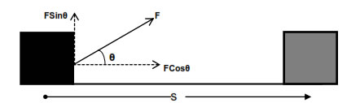
W = (Fcosθ) × s
W = FsCosθ

VECTOR DEFINITION OF WORK
Force and displacement both are vector quantities but their product, work is a scalar quantity, hence work must be scalar product or dot product of force and displacement vector.
W = F . s
Work is a scalar quantity, Its S1 unit is joule and CGS unit is erg.
∴ 1 joule = 10⁷ erg
Its dimensional formula is [ML²T⁻²].
Work done by a force is zero, if
(a) body is not displaced actually, i.e., s = 0
(b) body is displaced perpendicular to the direction of force, i.e.,
θ = 90°
Work done by a force is positive if angle between F and s is acute angle.
Work done by a force is negative if angle between F and s is obtuse angle.
Work done by a constant force depends only on the initial and final Positions and not on the actual path followed between initial and final positions.
Work done in different conditions
(i) Work done by a variable force is given by
W = ∫ F * ds
It is equal to the area under the force-displacement graph along with proper sign.
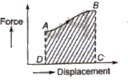
Work done = Area ABCDA
(ii) Work done in displacing any body under the action of a number of forces is equal to the work done by the resultant force.
(iii) In equilibrium (static or dynamic), the resultant force is zero therefore resultant work done is zero.
(iv) If work done by a force during a rough trip of a system is zero, then the force is conservative, otherwise it is called non-conservative force.
Power
The time rate of work done by a body is called its power.
Power = Rate of doing work = Work done / Time taken
If under a constant force F a body is displaced through a distance s in time t, the power
p = W / t = F * s / t
But s / t = v ; uniform velocity with which body is displaced.
∴ P = F * v = F v cos θ
where θ is the smaller angle between F and v.
power is a scalar quantity. Its S1 unit is watt and its dimensional formula is [ML²T⁻³].
Its other units are kilowatt and horse power,
1 kilowatt = 1000 watt
1 horse power = 746 watt

ENERGY
Capacity of doing work by a body is known as energy.
Note - Energy possessed by the body by virtue of any cause is equal to the total work done by the body when the cause responsible for energy becomes completely extinct.

TYPES OF ENERGIES
There are many types of energies like mechanical energy, electrical, magnetic, nuclear, solar, chemical etc.

MECHANICAL ENERGY
Energy possessed by the body by virtue of which it performs some mechanical work is known as mechanical energy. It is of basically two types-
(i) Kinetic energy
(ii) Potential energy

KINETIC ENERGY
Energy possessed by body due to virtue of its motion is known as the kinetic energy of the body. Kinetic energy possessed by moving body is equal to total work done by the body just before coming out to rest.
Kinetic energy = 1/2 mv²

KINETIC ENERGY IN TERMS OF MOMENTUM
K.E. of body moving with velocity v is
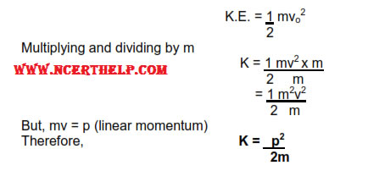

POTENTIAL ENERGY
Energy possessed by the body by virtue of its position or state is known as potential energy. Example:- gravitational potential energy, elastic potential energy, electrostatic potential energy etc.

GRAVITATIONAL POTENTIAL ENERGY
Energy possessed by a body by virtue of its height above surface of earth is known as gravitational potential energy. It is equal to the work done by the body situated at some height in returning back slowly to the surface of earth.
Consider a body of mass m situated at height h above the surface of earth. Force applied by the body in vertically downward direction is
F = mg
Displacement of the body in coming back slowly to the surface of earth is
s = h
Hence work done by the body is
W = FsCosθ
or, W = FsCos0
or, W = mgh
This work was stored in the body in the form of gravitational potential energy due to its position. Therefore
G.P.E = mgh

ELASTIC POTENTIAL ENERGY
Energy possessed by the spring by virtue of compression or expansion against elastic force in the spring is known as elastic potential energy.

Spring
It is a coiled structure made up of elastic material & is capable of applying restoring force & restoring torque when disturbed from its original state. When force (F) is applied at one end of the string, parallel to its length, keeping the other end fixed, then the spring expands (or contracts) & develops a restoring force (F_{r}) which balances the applied force in equilibrium.
On increasing applied force spring further expands in order to increase restoring force for balancing the applied force. Thus restoring force developed within the spring is directed proportional to the extension produced in the spring.
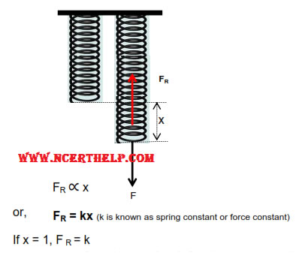
Hence force constant of string may be defined as the restoring force developed within spring when its length is changed by unity.
But in equilibrium, restoring force balances applied force.
F = F_{R} = k× x
If x = 1, F = 1
Hence force constant of string may also be defined as the force required to change its length by unity in equilibrium.

Mathematical Expression for Elastic Potential Energy
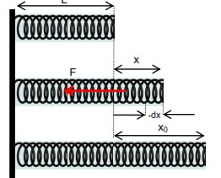
Consider a spring of natural length ‘L’ & spring constant ‘k’ its length is increased by x_{o}. Elastic potential energy of stretched spring will be equal to total work done by the spring in regaining its original length.
If in the process of regaining its natural length, at any instant extension in the spring was x then force applied by spring is
F = kx
If spring normalizes its length by elementary distance dx opposite to x under this force then work done by spring is
dW = F. (-dx) . Cos0
(force applied by spring F and displacement –dx taken opposite to extension x are in same direction)
dW = -kxdx
dW = -kxdx
Total work done by the spring in regaining its original length is obtained in integrating dW from x₀to 0
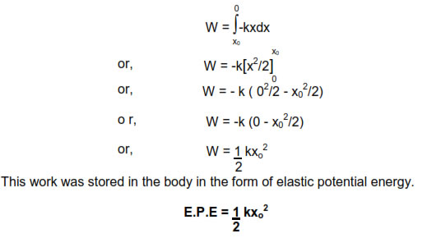

WORK ENERGY THEOREM
It states that total work done on the body is equal to the change in kinetic energy.(Provided body is confined to move horizontally and no dissipating forces are operating).
Consider a body of man m moving with initial velocity v₁ . After travelling through displacement s its final velocity becomes v₂ under the effect of force F.
